

Gulf Aluminium Rolling Mill Company
ICT Department

e-Bidding System

Software Requirements Specification

Version No.: 0.1
Revision History
Version | Date | Description of Change | Author
0.1 | 02 Feb. 10 | Draft | Noel

Reviewers
Name | Version Approved | Comments | Date

Table of Contents
1. Executive Summary 5
2. Introduction 6
2.1. Purpose 6
2.2. Audience 6
2.3. Document Conventions 6
2.4. Definitions, Acronyms, and Abbreviations 7
2.5. Project Scope 7
2.6. References 7
3. Overall Description 7
3.1. Project Perspective 7
3.1.1. System Interface 7
3.1.2. User Interface 7
3.1.3. Software Interface 7
3.1.4. Hardware Interface 7
3.1.5. Memory Constraints 7
3.1.6. Operations 7
3.2. Product Functions 9
3.3. User Characteristics 9
3.4. Design and Implementation Constraints 9
3.5. Assumptions and Dependencies 9
4. Specific Requirements 9
4.1. External Interfaces 9
4.2. Functional Requirements 9
4.2.1. e-Bidding Process 9
4.3. Performance Requirements 12
4.4. Design Constraints 12
4.5. Software System Attributes 13
4.5.1. Availability 13
4.5.2. Security 13
4.5.3. Maintainability 13
4.5.4. Portability 13
5. Development Phases 13
6. Change Management Process 13
7. Appendix 13

Table of Figures
Figure 1: e-Bidding Use Case 10

Executive Summary

Introduction

Purpose
This document delineates the different actors that will interact with the e-Bidding System, the Project, as well as their corresponding requirements.
Its purpose is to identify all the main functionalities of the system in which will guide the developers to create an effective detailed design and project development plan. It will also help the end-users to evaluate their needs to have a successful e-Bidding transaction.
In addition, it serves as a contract between the Project Team and the Project Sponsors, stating what will be delivered according to the budget, time constraints, risks, resources, and standards agreed upon for the Project.

Audience
This document is intended for Senior Management and Buyers for their perusal on various functionalities to be included in the Project as well as to identify any additional requirements that will boost the processing or routine of the system. This may also extend to Suppliers to get their feedbacks and needs for easy and smooth e-bidding transactions.
This is also intended for software developers to provide guidelines in designing the technical specifications of the Project in accordance to the requirements of users.

Document Conventions
All predefined words or keys are highlighted or written in Courier Bold.

Definitions, Acronyms, and Abbreviations

Project Scope

References

Overall Description

Project Perspective
This Project aims to provide GARMCO a huge savings on time in processing a “Request For Quotation” (RFQ). It aims to expedite the current manual process and to build more confidence with the Suppliers regarding the confidentiality of their biddings.
It will encourage the Supplier to re-evaluate its bidding by providing their current position, but not as rank, with the other Suppliers. Thus, it will provide financial savings to the company.

System Interface
Integration with existing systems such as the Enterprise One.

User Interface
Users will interact with the system through a Graphical User Interface (GUI) that is accessible through the use of an Internet browser such as Internet Explorer (IE) or Firefox.

Software Interface
The system will be developed using .NET Framework 3.5 and Telerik Controls for ASP.NET AJAX (If needed).

Hardware Interface
The system has no hardware interface requirements.

Memory Constraints
The Project will be designed to work on any modern computers, any computer capable of running MS Windows 98/2000/XP/Vista/7.

Operations
The modes of operations will be implemented for the Project namely: the Buyer, Supplier, Approver, and the Originator.
- Buyer
- Approving or rejecting the Supplier’s Registration
- Capable of submitting an RFQ for pending Purchase Requisition (PR)
- Selecting the Suppliers for the RFQ
- Creating a Bid Analysis
- Selecting the winning bidder
- Supplier, also known as Bidder
- Registering to the system
- Viewing all available RFQs for bidding
- Updating its profile
- Sending inquiry for additional information on RFQ
- Submitting, updating or withdrawing the bid
- Printing of Purchase Order (PO)
- Approver
- Approving or rejecting the winning bidder
- Originator
- Capable of submitting an RFQ
- Adding a Supplier to the current RFQ
- Replying to Supplier’s Inquiry for additional information on RFQ
- Selecting the winning bidder
- Canceling a PO

Product Functions

User Characteristics

Design and Implementation Constraints

Assumptions and Dependencies

Specific Requirements

External Interfaces

Functional Requirements
This Project ensures all users the following functionalities:
- To notify selected Suppliers automatically thru the use of Simple Mail Transfer Protocol (SMTP) service
- To protect the confidentiality of the Supplier’s bid by not showing the current bid amount to anyone until the closing date. In addition, the amount will be encrypted to include additional security up to the database level
- To assist each Supplier to reevaluate their current bid by providing their current position with other Suppliers, but not as rank number
- To provide the Suppliers a 24/7 accessibility in submitting or updating their bids
- To provide executive management additional control in finances by approving or rejecting the selected bidder regardless of its rank among the other bidders

e-Bidding Process

Workflow

Use Case
This Use Case diagram shows the different actors that will be involved in the e-Bidding process and their corresponding functions. Its main objective is to capture behavioral aspect of the system from a user’s point of view. This diagram can also be access from this link, http://grmdevtst1:8182.
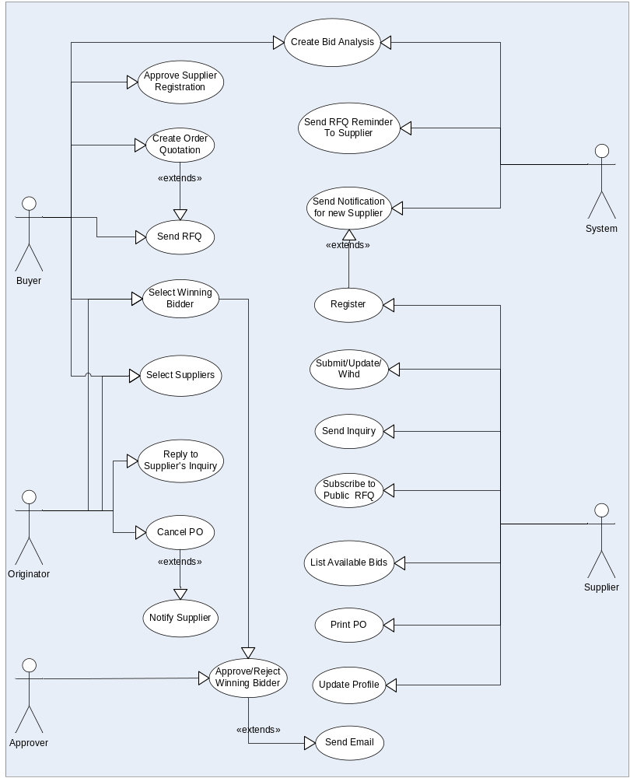
Figure 1: e-Bidding Use Case
The e-Bidding starts from submitting an RFQ to different suppliers which has been automatically selected initially by the system. Once an RFQ has been received by a registered Supplier, they start submitting their bid and update them as they like until such time an RFQ is closed. A Bid Analysis will be prepared either be the system or by the Buyer to select the lowest bidder. The selected winning bidder must be approved first by the Approver in case that it is not the lowest bidder. An email notification will be sent to the winning bidder and will be able to view the Purchase Order (PO). In other hand, an email notification will be sent also to other Suppliers who were not selected.

Use Case No. | 001 – Processing of RFQ | Level | Functional
Modified Date |  | Status
Initiating Actor | Buyer / Originator
Use Case Overview
An RFQ can be submitted by the Buyer or the Originator and a list of Suppliers will be selected automatically by the system based on the products or services a supplier provides. Invitation to bid will be sent thru SMTP to selected suppliers.
Pre-Conditions
- Suppliers must be registered in the system to be able to participate or selected in the e-Bidding process
Business Rules
- Every RFQ must have a closing date
- Supplier can re-evaluate their current bid as long it is not yet closing date
- All biddings will be hidden to Buyer and Originator until such time a Bid Analysis has been created. This will eliminate the possibility of providing a preferable Supplier information on the current bidding just to win
- The winning bidder must be approved first by the Approver if in the case he/she’s not the lowest bidder
Flow of Events
- The Originator / Buyer will create an Order Quotation (OQ) from Enterprise One or GARMCO Application Portal System
- Once an OQ is approved, Suppliers will be selected for an RFQ and email be sent to selected Suppliers as an invitation to bid
  - Other Registered Suppliers are also encourage to join the e-Bidding
- Suppliers will be able to view the RFQ
  - Supplier can send some inquiry for additional information on the RFQ
  - Submit their bidding and re-evaluate it if necessary
- Bid Analysis will be created once the closing date is reached
- Select the Supplier to whom the project will be awarded
  - An Approver must approved the winning bidder if it is not the lowest bidder
- An email will be sent to the winning bidder as well as to all bidders who participated in the e-Bidding
Alternate Flow of Events

Performance Requirements

Design Constraints
The Project will be developed using MS Visual Studio 2008 Professional / Team Suite Edition and using MS SQL 2005/2008 as the database backend. Host environment must have the following requirements:
- MS Windows 2008 Server (with Service Pack)
- .NET Framework 3.5

Software System Attributes

Availability
Any changes made within the module will be tested in a separate server environment before deploying to production server. In addition, all users will be notified through email regarding any updates so not to impede with their current operation. No necessary reinstallation will be done on users’ side.

Security
To maintain confidentially of data, Windows Domain Account will be used to access the system. This will save users for keeping additional accounts.

Maintainability
The Project will adhere to well known paradigms such as Model-View-Control (MVC) to ensure an easily maintainable system.

Portability
Portability is one of the premier points of the Project for it will not be highly dependent on users’ computer specification but rather on the server.

Development Phases

Change Management Process
Significant changes to the software requirements document shall be only be made when it is the consensus of the group that they are necessary and feasible. Any changes that will be included after the approval of this document will have an affect on the Project deliverables.

Appendix

